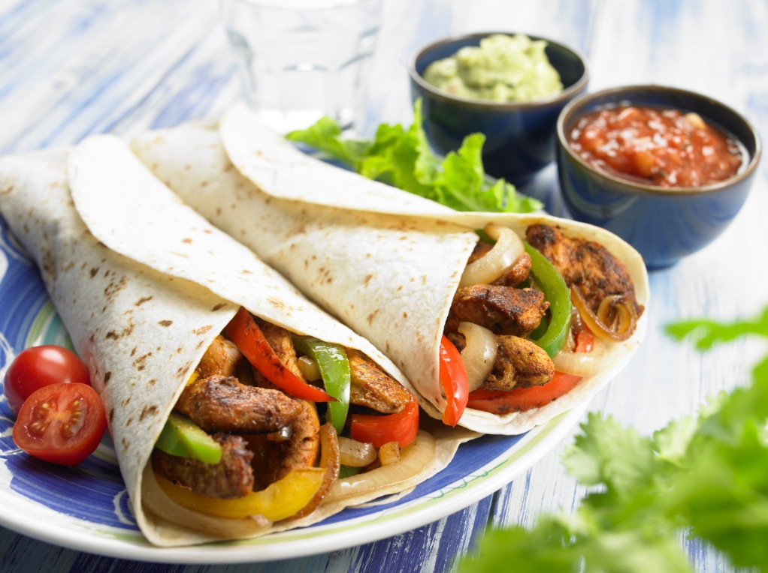

Chicken fajitas with spicy tomato salsa

Sizzling pan-grilled chicken strips with peppers and onions, wrapped in a flour tortilla.

Ingredients
Serves: 12
- 1200 g skinless boneless chicken breasts (fillets), cut in strips
- 4 garlic cloves, chopped
- 2 tsp ground cumin
- 2 tsp mild chilli powder
Tomato salsa
- 12 spring onions, thinly sliced
- 375 g ripe tomatoes, diced
- 3 medium-hot fresh green chilli, seeded and chopped, or to taste
- 6 tbsp. tomato passata
- 2 garlic cloves, chopped
- 1½ tsp ground cumin
- lemon juice to taste

- 2 tsp paprika
- 1/2 tsp dried oregano
- grated zest and juice of ½ orange
- juice of 1 lemon
- 6 tbsp. sunflower oil
- 90 g fresh coriander, chopped
- 6 green peppers, thinly sliced
- 6 onions, thinly sliced lengthways
- 24 flour tortillas
- 360 ml plain low-fat yogurt
- salt and pepper

Method
Prep:30min › Cook:30min › Ready in:1hr

- In a bowl combine the chicken strips with the garlic, cumin, chilli, paprika, oregano, orange zest and juice, lemon juice, 1 tbsp of the oil and 3 tbsp of the coriander. Mix well so that all the chicken strips are coated, then leave to marinate for at least 15 minutes.
- To make the salsa, combine all the ingredients. Add the remaining chopped coriander. Season with ¼–½ tsp lemon juice and some salt and pepper to taste. Set aside.
- Preheat the oven to 180°C (350°F, gas mark 4) and preheat the grill to high. Heat a ridged cast-iron grill pan or heavy-based frying pan until it is very hot. Brush with the remaining 1 tbsp of oil. Put in the green peppers and onions and cook for 6–8 minutes or until lightly charred. Remove from the pan and set aside.
- Wrap the tortillas, stacked up, in foil and put into the oven to warm for 10 minutes. Meanwhile, spread out the chicken in a shallow layer in the grill pan. Grill close to the heat, turning once or twice, for about 5 minutes or until thoroughly cooked.
- To serve, divide the chicken, onions and peppers among the warm tortillas and roll up. Serve with the fresh salsa and yogurt. Alternatively, present the ingredients separately, with the tortillas wrapped in a cloth to keep them warm, and let your guests make their own fajitas.

